Mohamed H.A. HASSAN

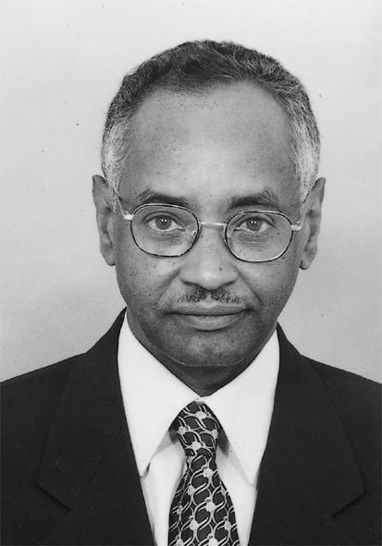

Executive Director, TWAS
The Academy of Sciences for the Developing World
Trieste, Italy
E-mail: mhassan@twas.org

EDUCATION
• B.Sc. (Special honours) in Mathematics, University of Newcastle-upon-Tyne, U.K. (1968).
• M.Sc. in Advanced Mathematics, University of Oxford, U.K. (1969).
• D.Phil. in Plasma Physics, University of Oxford, U.K. (1973).

PROFESSIONAL POSITIONS
• Executive Director, The Academy of Sciences for the Developing World (TWAS) [formerly the Third World Academy of Sciences] (1983-present)
• President, African Academy of Sciences (AAS) (2000-present)
• President, Network of African Science Academies (NASAC) (2001-present)
• Secretary General, Third World Network of Scientific Organizations (TWNSO) (1988-2006)
• Director of Secretariat, InterAcademy Panel (IAP) (2001-present)
• Chairman, Honorary Presidential Advisory Council for Science and Technology (appointed by the President of Nigeria) (2001-present)
• Chairman, Advisory Board of the United Nations University/Institute of Natural Resources in Africa (UNU/INRA) (2003-present)
• Chairman, Coordinating Council of the Commission on Science and Technology for Sustainable Development in the South (COMSATS) (1995-present)
• Board Member, International Science Programs (ISP) (1998-present)
• Board Member, Millennium Ecosystem Assessment (MA) (2000-present)
• Board Member, Science Initiative Group (SIG) (2004-present)

RESEARCH INTERESTS
• Plasma Physics
• Environmental Modelling of Soil Erosion in Drylands

HONORS & AWARDS
• Fellow of the Third World Academy of Sciences (from 1985).
• Founding Fellow of the African Academy of Sciences (from 1985).
• Fellow of the Islamic World Academy of Sciences (from 1992).
• Hon. Member, Academia Colombiana de Ciencias Exactas, Fisicas y Naturales (from 1996).
• Corr. Member, Académie Royale des Sciences d'Outre-Mer, Belgium (from 2001).
• Foreign Fellow, Pakistan Academy of Sciences (from 2002).
• Comendator, Ordem Nacional de Mérito Cientifico, Brazil (from 1996).
• Cavaliere Ufficiale dell'Ordine al Merito della Repubblica Italiana, Italy (from 2003).
• Classe da Grã-Cruz na Ordem Nacional do Mérito Cientifico (from April 2005).
• Honorary Member, Palestine Academy of Science and Technology, Palestine (from May 2005).

