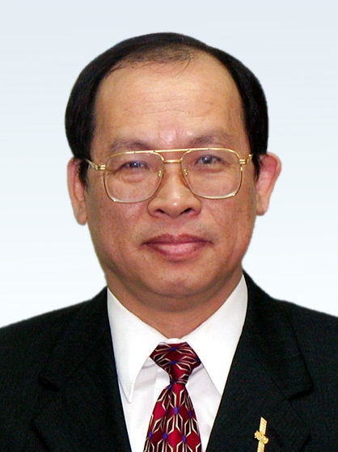
Lou-Chuang Lee

EDUCATION:
Ph. D. Physics, California Institute of Technology, 1975
M. S. Physics, California Institute of Technology, 1972
B. S . Physics, National Taiwan University, 1969
EXPERIENCE:
- Minister, National Science Council, Executive Yuan, 2008-present
- Professor, Graduate Institute of Space Science, National Central University, 2006-present
- President, National Central University, 2006-2008
- President, National Applied Research Laboratories, 2003− 2006.
- Chief Scientist, National Space Program Office, Taiwan, ROC, 1997−2001; Director 2001−July 2004.
- Dean, College of Science, National Cheng Kung University, 1995–2001; Professor 1995−2005.
- Professor, Geophysical Institute and Department of Physics, University of Alaska, 1978–1995.
- Visiting Assistant Professor, Institute for Physics Science and Technology, University of Maryland, 1977– 1978.
- Research Associate, NASA/Goddard Space Flight Center, 1975–1977.
HONORS AND AWARDS:
- Fulbright Distinguished Scholar, 1988.
- Academic Award, Ministry of Education, Taiwan, ROC, 2001.
- Academician, Academia Sinica, Taiwan, ROC, 2002.
- Presidential Science Prize, Taiwan, ROC, 2005.
- Fellow, The Academy of Sciences for the Developing World（TWAS）, 2006.

