萬其超（Chi-Chao Wan）教授簡介

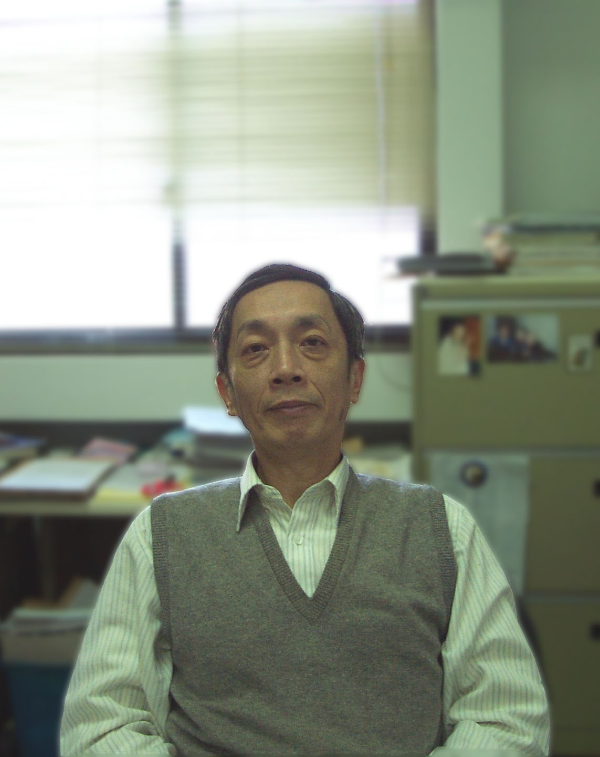

University Professor
Departments of Chemical Engineering
National Tsing Hua University
E-mail: ccwan@mx.nthu.edu.tw

EDUCATION
▪ Columbia University (Chemical Engineering), 1972 to 1974
▪ Columbia University (Chemical Engineering), M.S., 1970 to 1972
▪ National Taiwan University (Chemical Engineering), B.S., 1965 to 1969
PROFESSIONAL POSITIONS
Current
▪ Tsing Hua Professor of Engineering, 2003-
▪ Department of Chemical Engineering, National Tsing Hua University, Professor, 1979-
▪ Science and Technology Advisory Group of Excusive Yuan, Executive Secretary, 2008-
▪ K. T. Li Foundation for the Development of Science and Technology, Secretary General, 1991-
Past
▪ Sustainable Development Research Committee, National Science Council, Executive Secretary, 1999-2007
▪ Cooperative Applied Research Office, National Science Council, Executive Secretary, 1999-2007
▪ National Tsing Hua University, Secretariat of Administration, 1994-1995
▪ Material Science Center, National Tsing Hua University, Director, 1985-1986
▪ Committee of General Education, National Tsing Hua University, Chairperson, 1992-1994
▪ Research & Development Office, National Tsing Hua University, Head, 1985-1988
▪ College of Engineering, National Tsing Hua University, Dean, 1988-1992
▪ Department of Chemical Engineering, National Tsing Hua University, Chairman, 1981-1982
▪ Department of Chemical Engineering, National Tsing Hua University, Associate Professor, 1974 to 1979
RESEARCH INTERESTS
▪ Dye-sensitized Solar Cell
Study on TiO₂ anode structure, Pt-nanoparticles modified cathode structure and their efficiency.
▪ Fuel Cell
Model development for direct methanol fuel cell (DMFC) simulating; Synthesis of Pt-based catalyst for DMFC; and macroscopic scale dynamic model for polymer electrolyte membrane fuel cell (PEMFC)
▪ Surface treatment of IC fabrication
Application of electrochemical analysis and theories to investigate the fabrication of void-free copper interconnects by electrochemical plating.
▪ Surface treatment of PCB
Non-ammonia etchants are used to replace conventional etchant. The using of non-ammonia agents is not only to reduce the fume volatilization, but also inhibit the side etching, which to exhibit the banking effect for fine line fabrication.
▪ Direct Plating
The direct plating technique can replace electroless plating in PCB process. The detailed mechanism is also of interest.

HONORS & AWARDS
▪ Distinguished Researcher Fellow of National Science Council, 2002
▪ Award for Excellent Teaching of Tsing Hua University, 2001
▪ Research Fellow, National Science Council, 1995
▪ Outstanding Research Award, National Science Council, 1993
▪ Outstanding Research Award, National Science Council, 1991
▪ Outstanding Research Award, National Science Council, 1989
▪ Outstanding Research Award, National Science Council, 1986
▪ Lai Tsai-Teh Award

