彭宗平（Tsong-Pyng Perng）博士簡介
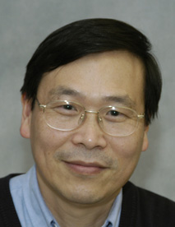 | President  Yuan Ze University  E-mail: wtyfnd@ms61.hinet.net
EDUCATION
1984 Ph.D. in Materials Science and Engineering, University of Illinois at Urbana-Champaign
1981 M.S. in Materials Science and Engineering, University of Texas at Austin
1976 B.S. in Chemistry, National Taiwan University
PROFESSIONL EXPERIENCES
2005-present President, Yuan Ze University
1998-2004 Dean of Academic Affairs
1994-1997 Chairman, Department of Materials Science and Engineering
1991-present Professor, National Tsing Hua University
1985-1991 Associate Professor, National Tsing Hua University
1983-1985 Consultant, Disk-Tee Inc., Champaign, IL
1983-1985 Consultant, NOXSO Corp., Paducah, KY
1984-1985 Research Associate, University of Illinois
1978-1979 Engineering Supervisor, Grand Dacrotized Products, Co., Ltd.
1978 Nippon Dacrotized Co., Japan
HONORS
▪ Outstanding Research Award (1993), National Science Council
▪ Outstanding Teaching Award (1991), National Tsing Hua University
▪ Outstanding Service Award (1997), Chinese Materials Science Societ

