李定國（Ting-Kuo Lee）博士簡介
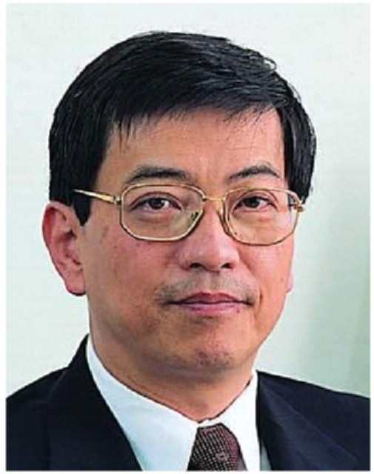 | Distinguished Research Fellow  Institute of Physics, Academia Sinica  E-mail: tklee@phys.sinica.edu.tw
EDUCATION
1975 Ph.D. in Physics, Brown University.
1971 B.S., National Taiwan University.
PROFESSIONAL EXPERIENCES
2004-present Distinguished Research Fellow, Institute of Physics, Academia Sinica
2004-2006 Executive Director, National Science and Technology Program for Nanoscience and Nanotechnology
2001-present Adjunct Professor, National Tsing Hua University
1998-present Adjunct Professor, National Taiwan University
1997-2003 Head, Physics Division, National Center for Theoretical Sciences, Hsinchu
1996-2004 Research Fellow, Institute of Physics, Academia Sinica
1982-1997 Faculty, Virginia Polytechnic Institute and State University
1979-1981 Research Associate, Institute for Theoretical Physics, University of California, Santa Barbara, California
1975-1979 Research Associate, Dept. of Physics, City College of City Univ. of New York, New York.
HONORS
1997-2002 Outstanding Scholar Award by Foundation for the Advancement of Outstanding Scholarship, Taipei, Taiwan
2003 NSC Outstanding Research Award
2004 Fellow, American Physical Society
2005 Ho Chin Tui Award for Academic Research
2006 Fellow, Institute of Physics, UK

