錢煦（Shu Chien）院士簡介
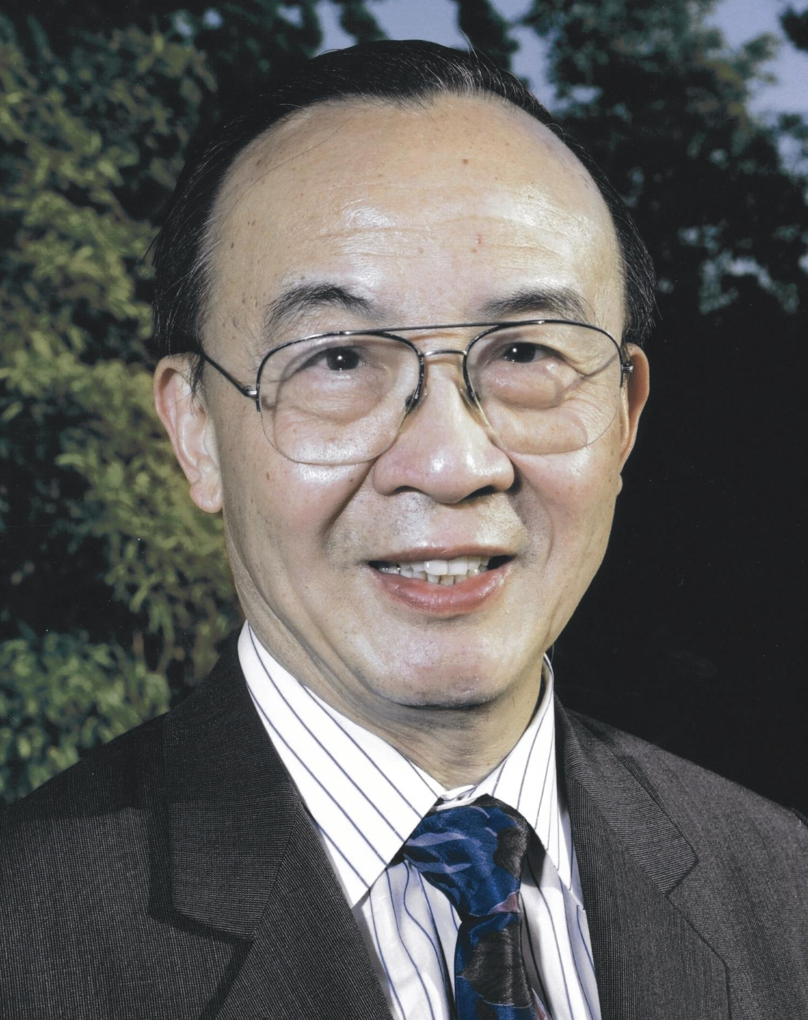 | University Professor and Y.C. Fung Professor  Departments of Bioengineering and Medicine  University of California, San Diego  E-mail: shuchien@ucsd.edu
EDUCATION
▪ National Peking University (Premed.), 1947 to 1948.
▪ National Taiwan University (College of Medicine), M.B., 1953
▪ Columbia University (Physiology), Ph.D., 1957
PROFESSIONAL POSITIONS
▪ National Taiwan University Hospital, Rotating Intern (1952-1953)
▪ Columbia University College of Physicians & Surgeons (Dept. of Physiology): Instructor (1956-1958), Assistant Professor (1958-1964), Associate Professor (1964-1969), Professor (1969-1988)
▪ University of California, San Diego: Professor of Bioengineering & Medicine (1988- ) Chair, Department of Bioengineering (1994-1999, 2002-2005), Director, Whitaker Institute of Biomedical Engineering (1991- )
▪ University of California: University Professor (2002- ), Director, Bioengineering Institute of California (2004- )
RESEARCH INTERESTS
Effects of mechanical forces on gene expression and signal transduction. Integrative and systems physiology. Molecular, cellular and tissue bioengineering.
HONORS & AWARDS
▪ Li Foundation Fellow (1954-1956)
▪ Teacher of the Year, Columbia Univ. College of Physicians & Surgeons (1972, 1974, 1981, 1983)
▪ Academia Sinica (Taipei): Member (1976- ); Director, Institute of Biomedical Sciences (1987-1988)
▪ American Chinese Medical Society: President (1978-1979)
▪ Chinese Academic and Professional Association: President (1979-1980)
▪ Microcirculatory Society: President (1980-1981); Landis Award (1983)
▪ European Society for Clinical Hemorheology: The 1st Fahraeus Medal (1981)
▪ American Society of Mechanical Engineers: Melville Medals (1990, 1996)
▪ Vth World Congress for Microcirculation: Zweifach Award (1991)
▪ American Institute of Medical and Biological Engineering: Founding Fellow (1992- ); President (2000-2001); Pierre Galletti Award (2004)
▪ Federation of American Societies for Experimental Biology (FASEB): President (1992-1993)
▪ Biomedical Engineering Society: ALZA Award (1993); Distinguished Service Award (2001); President (2006-2008)
▪ Institute of Medicine (National Academy of Sciences): Member (1994- )
▪ San Diego Chinese Historical Museum: Chair of the Board (1995-1996)
▪ Honorable Visiting Scientist, National Science Council, Taiwan (1995)
▪ Honorary Professors: Peking Medical University (1995); Chungqing University (1995); Microcirculation Laboratory, Chinese Academy of Medical Sciences (1997), Sicuan University (2004), Peking Union Medical University (2005), Peking University (2005), National Yang-Ming University (2006), JiaoTung University (2006)
▪ National Academy of Engineering: Member (1997); Founders’ Award (2006)
▪ Department of Health, Taiwan: National Health Medal (1998)
▪ American Physiological Society: President (1990-1991); Ray Daggs Award (1999); Walter B. Cannon Lecturer (2003)
▪ International Society of Biorheology: Poiseuille Gold Medal (2002); President (2005-2008)
▪ Chinese Association of Physiological Sciences (Beijing): Honorary Member (2003)
▪ Chinese Physiological Society (Taipei): Honorary Member (2004)
▪ Asian American Engineer of the Year, U.S.A. (2005)
▪ UCSD Jacobs School of Engineering: Phi Beta Tau Professor of the Year (2005)
▪ National Academy of Sciences: Member (2005)
▪ American Academy of Arts and Sciences: Fellow (2006)
▪ Honorary Doctoral Degrees: Chung-Yuan Christian Univ. (2006); National Taiwan Univ. (2006).
▪ Chinese Academy of Science (PRC): Foreign Member (2006)
▪ Society of Chinese Bioscientists in American (SCBA): Lifetime Achievement Award (2006)

