劉江（Kiang Liu）博士簡介
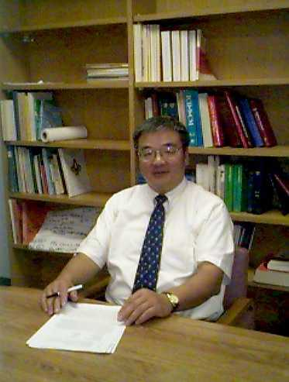 | Professor and Associate Chair for Research  Dept. of Preventive Medicine,  Feinberg School of Medicine,  Northwestern University  E-mail: kiangliu@northwestern.edu
EDUCATION
1970 Fu Jen University (Mathematics), B.S.
1976 University of North Carolina, Chapel Hill, NC (Statistics), Ph.D.
PROFESSIONAL POSITIONS
1976-1979 Postdoctoral Fellow, Cardiovascular Epidemiology, Biostatistics, Nutrition, & Preventive Cardiology, Department of Community Health & Preventive Medicine, Northwestern University Medical School, Chicago, IL
1979-1983 Assistant Professor, Department of Community Health & Preventive Medicine, Northwestern University Medical School, Chicago, IL
1983-1988 Associate Professor, Department of Community Health & Preventive Medicine, Northwestern University Medical School, Chicago, IL
1988-present Professor, Department of Preventive Medicine, Northwestern University Medical School, Chicago, IL
1996-present Professor, Department of Medicine, Northwestern University Medical School, Chicago, IL
2004-present Associate Chair for Research, Department of Preventive Medicine, Northwestern University Medical School, Chicago, IL (2004-present)
HONORS & PROFESSIONAL MEMBERSHIPS
1979-1984 Research Career Development Award, National Heart, Lung, & Blood Institute
1981-present Fellow, Council on Epidemiology, American Heart Association
1988-1992 Member, Epidemiology & Disease Control Study Section, National Institutes of Health
1998-present Elected Member, American Epidemiology Society
2006 Distinguished Alumni Award, Fu- Jen University, Taiwan (2006)

