錢肯（Kenneth R. Chien）博士簡介
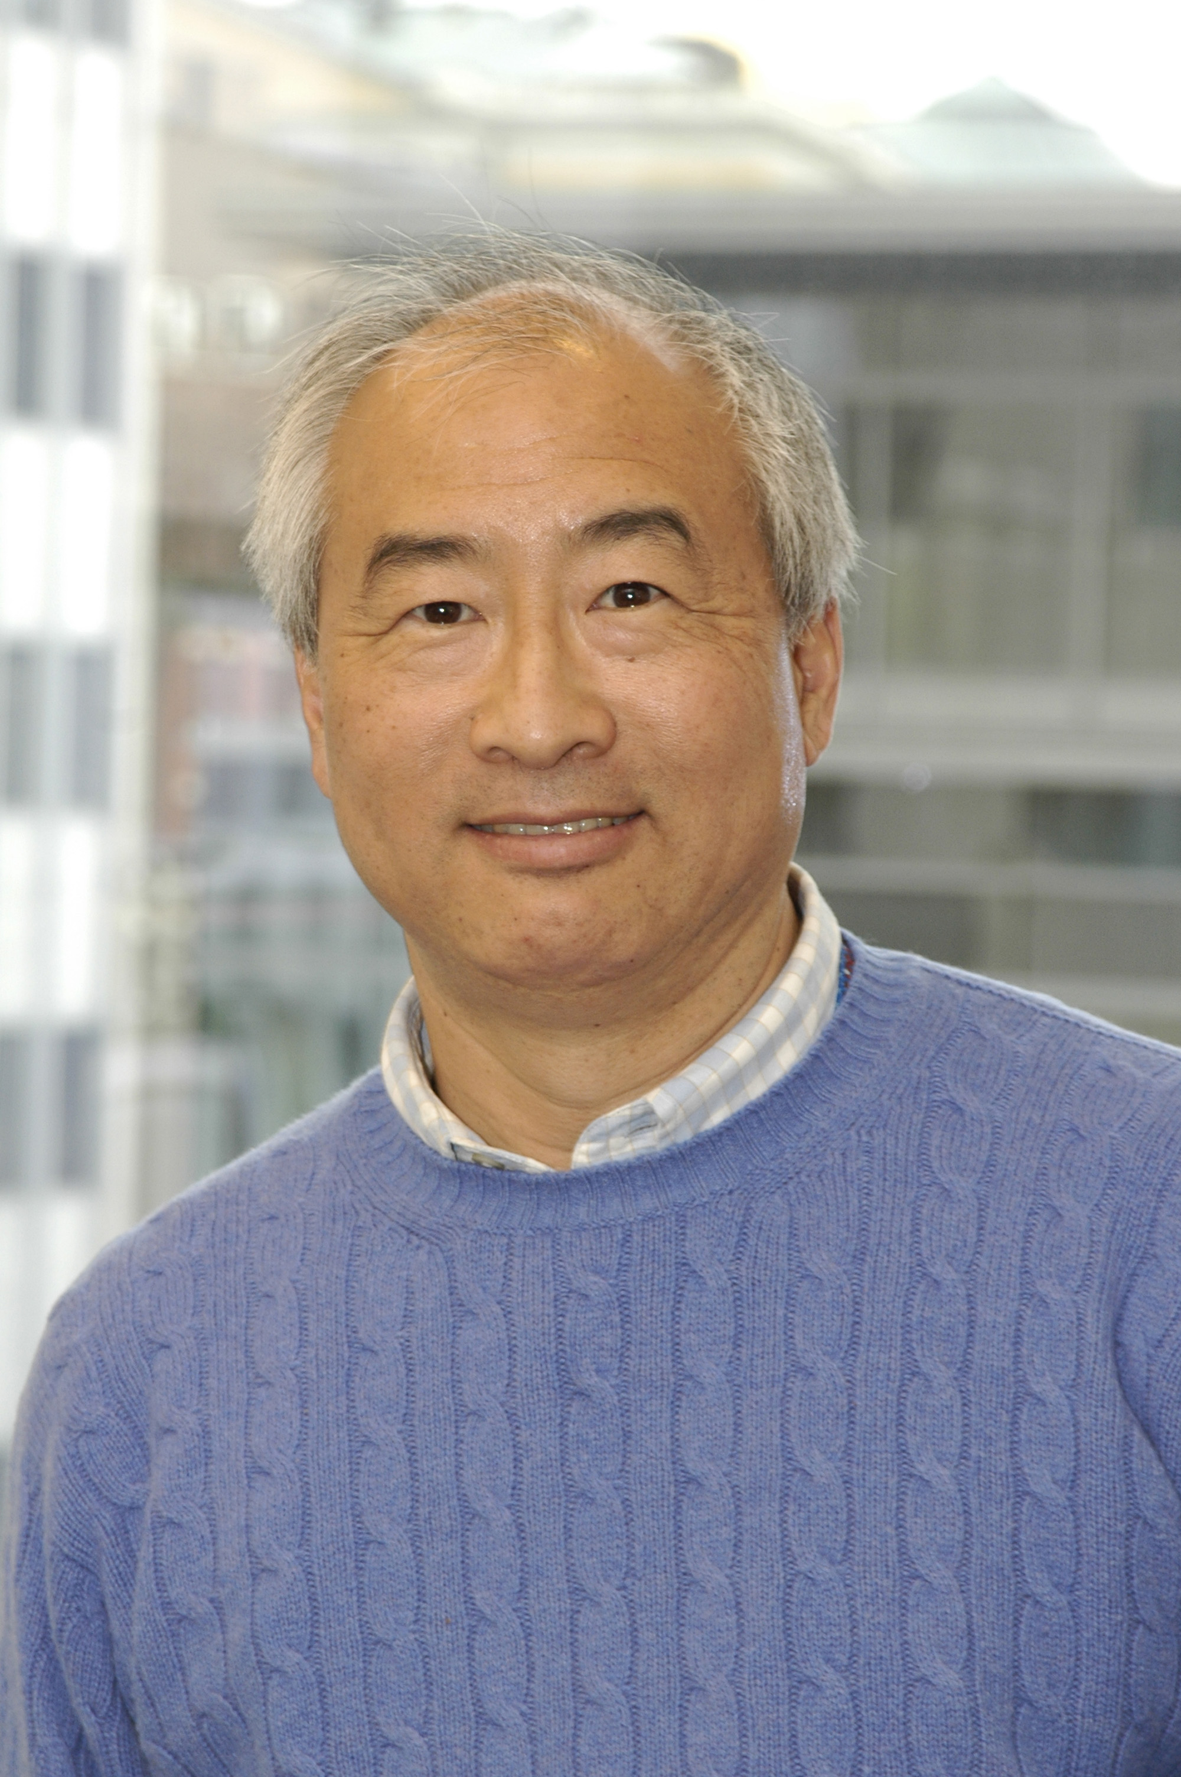 | Director  Cardiovascular Disease Program  Harvard Stem Cell Institute;  E-mail: kchien@partners.org
EDUCATION
1969-1973 B. A., Harvard College
1973-1980 M. D., Temple University School of Medicine
1975-1983 Ph.D., Temple University School of Medicine
1980-1981 Internship (Medicine), Parkland Memorial Hospital, Dallas, TX
1981-1982 Residency (Medicine), Parkland Memorial Hospital, Dallas, TX
1982-1984 Clinical-Research Fellowship (Cardiology), University of Texas Southwestern, Medical Center, Dallas, TX
ACADEMIC APPOINTMENTS
1984-1988 Assistant Professor of Medicine, Cardiology Division, University of Texas Southwestern Medical Center, Dallas, TX
1988-1992 Associate Professor of Medicine, Department of Medicine and Member, Center for Molecular Genetics, University of California, San Diego, La Jolla, CA
1992-2005 Professor of Medicine, Department of Medicine and Member, Center for Molecular Genetics, University of California, San Diego, La Jolla, CA
2000-present Professor, Salk Institute (Adjunct)
2005-present Professor of Medicine, Harvard Medical School
2005-present Charles Sanders Endowed Chair in Medicine, Harvard Medical School
2005-present Professor, Department of Cell Biology, Harvard Medical School
2006-present Director, Cardiovascular Disease Program, Harvard Stem Cell Institute
AWARDS & HONORS
1971 National Science Foundation Undergraduate Research Fellowship
1971 Williams Essay Prize
1972 Harvard College Fellowship
1978 Mead-Johnson National Student Research Prize, Honorable Mention
1983 Kern Wildenthal Award
1983 Texas College of Physicians Research Prize
1984-1988 NHLBI Clinical Investigator Award
1984 Burroughs-Wellcome Southern Society of Clinical Investigation Prize
1985 Lamport Award (American Physiological Society) for outstanding young investigator under 36 years of age
1988-1993 Established Investigator Award of the American Heart Association
1995 NHLBI Distinguished Service Citation
1996 The Pasarow Foundation Medical Research Award (Co-recipients: Stanley Prusiner (Neuroscience) and Alfred G. Knudson (Cancer)
1996 American Heart Association-United Way Combined Health Agency Health Hero Award
2000 The Temple University Alumni Achievement Award, Philadelphia, PA
2000-present American Heart Association Endowed Chair in Cardiovascular Research (California Affiliate)
2003 Temple University Alumni Assoc. School of Medicine Certificate of Honor, Philadelphia, PA

