吳華林（Hua-Lin Wu）博士簡介
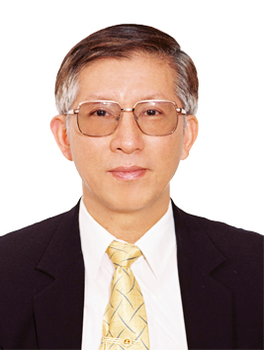 | Distinguished Professor  Dept. of Biochemistry and Molecular Biology  College of Medicine  National Cheng Kung University  E-mail: halnwu@mail.ncku.edu.tw
EDUCATION
1972 B. S., National Taiwan University, Medical Technology
1974 M. S., National Taiwan University, Biochemistry
1980 Ph.D., Ohio State University, Biochemistry, USA
PROFESSIONAL POSITIONS
▪ Northwestern University, USA: Postdoctoral Fellow (1980-1983)
▪ National Cheng Kung University: Associate Professor (1983-1988), Chairman of Medical Technology (1989-1995) and Biochemistry (1996-1999), Professor (1998-present), Director of Cardiovascular Research Center (2006-present), Deputy Director of Center for Bioscience and Biotechnology (2003-present)
▪ Board of Directory Committee at The Taiwan Society for Biochemistry and Molecular Biology (2001-present)
▪ Editorial Advisory Board Member of Cardiovascular and Hematological Agent in Medicinal Chemistry (2005-present)
▪ Director of Program Project at National Science Council (2002-2010)
▪ Scientific membership of The Taiwan Society for Biochemistry and Molecular Biology, The Taiwan Society for Cell and Molecular Biology, The American Society for Biochemistry and Molecular Biology, The American Society for Cell Biology, and International Society of Thrombosis and Haemostasis.
RESRACH INTEREST
▪ The biological functions of thrombomodulin and angiostatin.
▪ The mechanisms of thrombomodulin-mediated tumor cell proliferation, migration and signal transduction.
▪ The correlation of gene polymorphisms, gene expressions and atherosclerosis.
HONORS & AWARDS
- National Science Council Excellent Research Award (1988，1992，1994)
- National Science Council Outstanding Research Award (1998-1999)
- William Harvey Prize (1995)
- San-Lien Wu Awards Foundation Medical Award (2001)
- National Science Council outstanding technology transfer contribution prize (2005)

