葉篤行（Edward T.H. Yeh）院士簡介
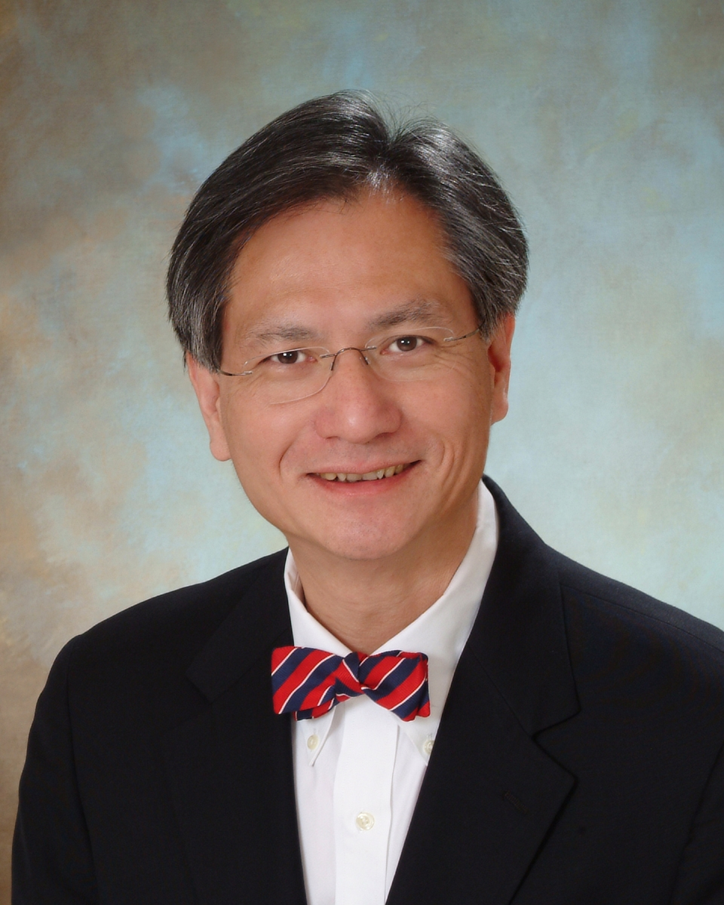 | Professor & Chairman  Dept. of Cardiology,  The University of Texas, M. D. Anderson Cancer Center  E-mail: etyeh@mdanderson.org
EDUCATION
1973-1976 University of California, Berkeley (Biochemistry), B. S.
1976-1980 University of California-Davis (School of Medicine), M.D.
PROFESSIONAL POSITIONS
1983-1986 Research fellow in Immunology under Nobel laureate Dr. Baruj Benacerraf (1980) at Harvard Medical School, Boston
1986-1987 Clinical research fellow on rheumatism at the Massachusetts General Hospital and Harvard Medical School
1987-1992 Assistant Professor of Medicine at the Massachusetts General Hospital and Harvard Medical School
1992-1995 Clinical Research fellow on cardiology in the University of Texas-Houston Health Science Center
1992-1998 Associate Professor in the University of Texas Medical School at Houston
1998-2000 Full Professor in the University of Texas Medical School at Houston
2000-present Professor and Chairman, Department of Cardiology at the University of Texas M. D. Anderson Cancer Center
FIELDS OF SPECIALITY
Cardiovascular Diseases, Nuclear Cardiology, Internal Medicine
HONORS & AWARDS
▪ Kraft Prize for Undergraduates at U.C. Berkeley
▪ Investigator Award, Arthritis Foundation (1987-1990)
▪ Upjohn/Massachusetts General Hospital Scholar Award (1987-1990)
▪ Established Investigator Award, American Heart Association (1992-1999)
▪ American Society of Clinical Investigation (1993)
▪ Association of American Physicians (2000)
▪ Distinguished Alumnus Award, U. C. Davis Medical School (2000)
▪ “A Conversation with a Living Legend” Professor, the University of Texas M. D. Anderson Cancer Center (2001)
▪ Academician, Academia Sinica (2006)

