沈君山（Chun-Shan Shen）博士簡介
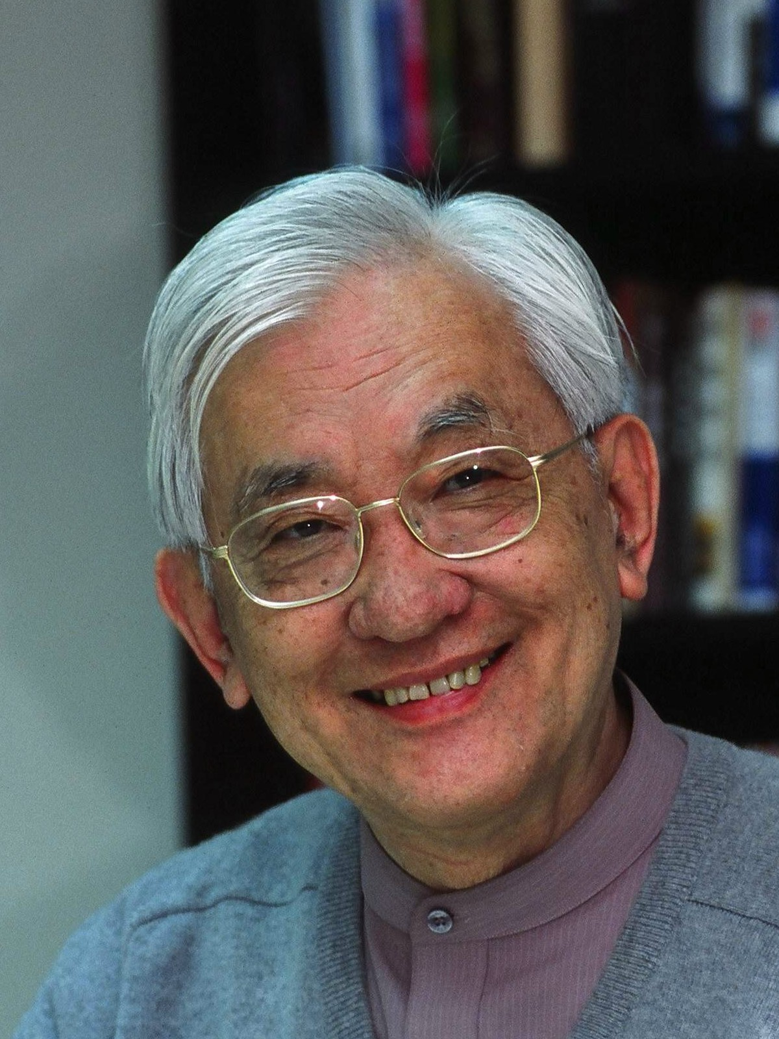 | Wu Ta-You Foundation  E-mail: wtyfnd@ms61.hinet.net
EDUCATION
1961 Ph.D. in Department of Physics, University of Maryland, USA
1955 B. A. in Department of Physics, National Taiwan University
PROFESSIONAL EXPERIENCES
2001-2006 Chairman, Wu Ta-You Foundation
1999-present Chairman, New Taiwanese Cultural Foundation
1999-2005 President, Chinese GO Association (Taipei)
1998-2001 Yu-Kuo-Hwa Professor, National Tsing Hwa University
1993-1998 President, National Tsing Hwa University
1988-1989 Minister without Portfolio, Executive Yuan, Taiwan
1984-1987 Dean, College of Science, National Tsing Hwa University
1973-1979 Dean, College of Science, National Tsing Hwa University
1973-1998 Professor, National Tsing Hwa University
1968-1972 Associate Professor, Physics Department, Purdue University
1964-1968 Assistant Professor, Physics Department, Purdue University
1962-1964 Research Associate, Institute for space studies, NASA
1961-1962 Research Associate, Princeton University
OTHER EXPERIENCE
1997-2000 Chairman, Wu Chien-Shiung Education Foundation
1998-present Honorable Chairman, Chinese Contract Bridge League
1988-1995 Council Member, Academia Sinica, R.O.C.
1990-1996 Research Member, National Unification Council
1989-1995 Commissioner, Central Election Committee, R.O.C.
1989-1996 Member of standing Committee, Chinese Contract Bridge League
1987-1998 Vise President, Chinese Go Society (Taipei)
1980-1989 Election Commissioner of Taiwan Province, R.O.C

