Reactive-Ion Etching (RIE)
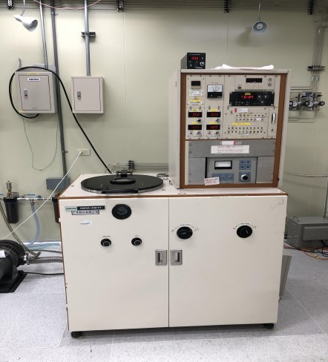

This machine provides surface etching. The following etching gases O2, Ar, CF4 and SF6 are used for sample etching. Sample size is limited to eight inches in diameter.

1,500 NT/Hr

