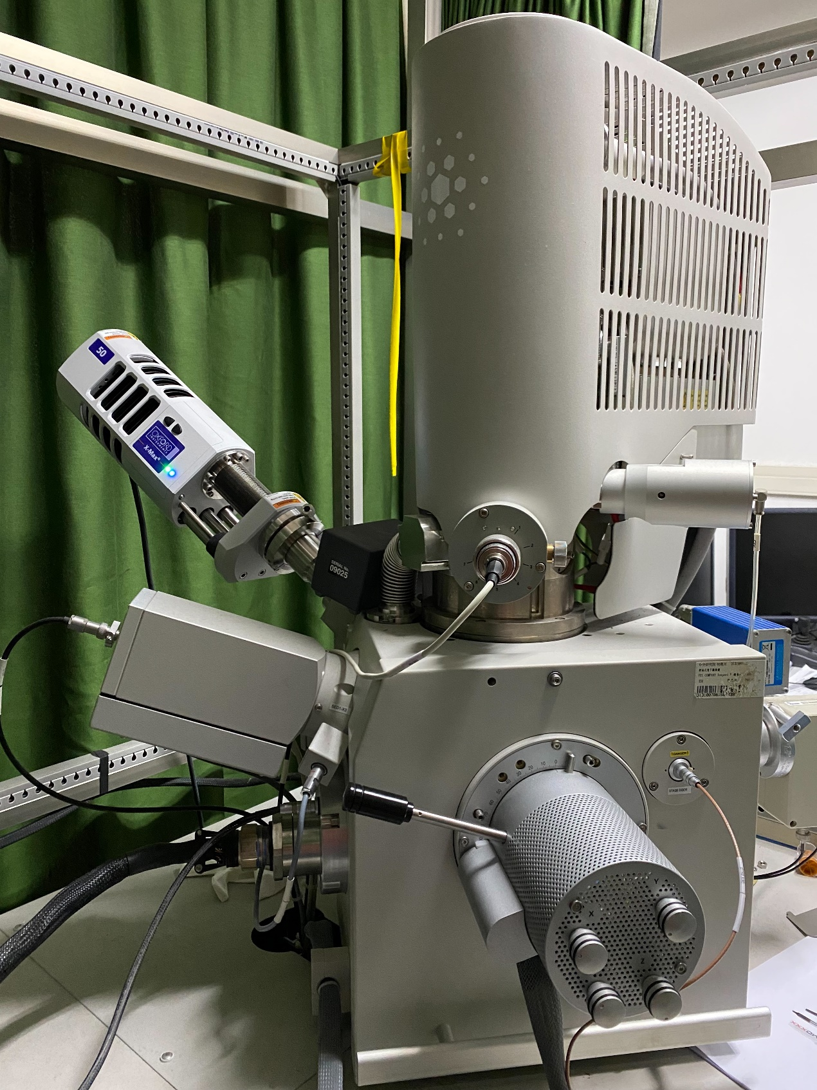
掃描電子顯微鏡提供奈米尺度解析度的影像。適合的材料為塊材狀導體，非導體、粉末狀、鐵磁性材料均禁止使用本設備觀察。
The SEM provides images with nanometer scale resolution. Suitable materials are bulk conductor. Non-conductor, powdery and ferromagnetic material are forbidden.

廠牌型號(Brand/Model)：FEI InspectF SEM
燈絲類型(Emitter type)：Schottky type field emission gun
加速電壓(Acceleration voltage)：1 kV ~ 30 kV
附加設備(Additional equipment)：AZtech X-MaxN 50 EDS

收費：儀器保養與維修費用由使用者所屬實驗室分攤，分攤比例依照各實驗室使用比例計算。
Cost fee: The maintenance and repair costs of the instrument are shared by the laboratory to which the user belongs, and the sharing ratio is calculated in accordance with the usage ratio of each laboratory.

