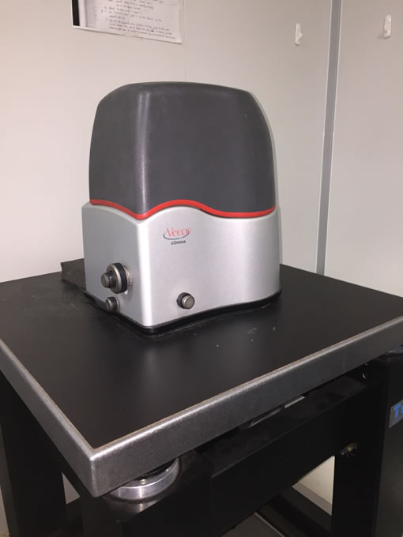
原子力顯微鏡可提供在x-y平面具有奈米解析度在z軸上有埃米解析度的樣品表面形貌分析。這款AFM擅長掃描凝態材料，不建議用於液相環境或軟物質材料。
註：掃描探針為耗材，使用者需自備。
The AFM provides surface morphology and topography of sample with nanometer scale resolution on x-y plane and angstrom resolution on z-axis. This AFM is good at scanning condensed materials and is not recommended for liquid-phase environments or soft materials.
PS. The scanning probes are consumable goods and users have to bring their own.

廠牌型號(Brand/Model)：Bruker Innova
掃圖模式(Scanning mode)：Tapping and contact mode
成像範圍(Imaging range)：100 x 100 x 7 μm³.

收費：儀器保養與維修費用由使用者所屬實驗室分攤，分攤比例依照各實驗室使用比例計算。
Cost fee: The maintenance and repair costs of the instrument are shared by the laboratory to which the user belongs, and the sharing ratio is calculated in accordance with the usage ratio of each laboratory.

