Nanoscale ultra-thin film network provides a novel approach to enhance the critical field of superconductors
The ability for a superconductor to survive under high magnetic fields is crucial for its applications. A team of researchers from US and Academia Sinica has found a method to boost the critical field of superconductor. The researchers used the molecular beam epitaxial (MBE) technique to grow the single crystalline Pb into a nano-mesh of 2nm thickness. By using low temperature scanning tunneling microscope, mutual inductance measurements and magneto-transport measurements, the researchers found that the Pb nano-mesh maintains strong global phase rigidity, thus retaining the Tc close to that of a bulk crystal. The parallel critical field is significantly higher than the Clogston limit as a direct consequence of ultra-thin geometry and strong spin orbital coupling. In the perpendicular field, the orbital pair breaking is also quenched until the magnetic length becomes smaller than the lateral dimension of the nano-mesh. The inverse correlation of the lateral width and local H_{C⏊} points to a possibility to achieve much higher H_{C⏊}. This work demonstrates that superconductivity pair breaking can be significantly suppressed by nanoscale engineering and opens new strategies to optimize superconducting quantum devices.
These findings have now been published in the journal Nature Communication. The collaboration consists of Prof. Chih-Kang Shih (University of Texas), Prof. Allan MacDonald (University of Texas), Prof. Hua Chen (Colorado State University), Prof. Philip Adams (Louisiana State University) and the Surface Science Group at the Institute of Physics, Academia Sinica (Dr. Syu-You Guan, Dr. Tien-Ming Chuang and Director Chia-Seng Chang). The work at Institute of Physics is supported by Ministry of Science and Technology and Academia Sinica. Dr. Tien-Ming Chuang also acknowledges the support from Kenda Foundation and Dr. Syu-You Guan is now the recipient of postdoctoral fellowship from Academia Sinca.
More information: Nam et al., Nature Communications 9, 5431 (2018).
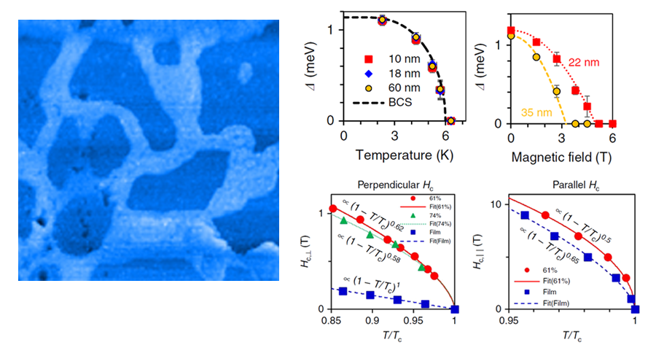
奈米超薄網格結構提供增強超導臨界磁場之新方法
超導體在高磁場下維持其超導特性的能力對其應用至關重要。中央研究院物理所表面組參與國際合作發現了一種提升超導體臨界磁場的方法。研究人員使用分子束磊晶(MBE)技術將鉛生長成2nm厚的單晶奈米網格後，藉由低溫掃描穿隧顯微鏡(STM)、互感(mutual inductance)和電性傳輸測量發現樣品保持極強的巨觀相位剛性(phase rigidity)，進而保持樣品超導溫度(Tc)仍然接近塊材之Tc。同時由於超薄幾何結構和強自旋軌道耦合的關係，鉛奈米網格之平行臨界磁場明顯高於Clogston極限。而在垂直磁場下，軌道配對破壞效應也被抑制，直到磁長度小於奈米網格的橫向尺寸。網格橫向寬度與垂直臨界磁場的逆相關顯示此方法可能進一步提高垂直臨界磁場。這項工作展示類似奈米結構可用來優化超導量子元件特性。
此研究成果已發表在自然通訊期刊(Nature Communications)。合作團隊包括德州大學施至剛教授、Allan MacDonald教授、科羅拉多州立大學Hua Chen教授、路易西安納州立大學Philip Adams教授與中央研究院物理所表面組關旭佑博士、莊天明博士、張嘉升所長。物理所的研究部分是由中央研究院與科技部經費補助。關旭佑博士目前為中央研究院博士後研究學者，莊天明博士感謝建大文教基金會的支持。
期刊論文連結: Nam et al., Nature Communications 9, 5431 (2018).

